- Bluebook Page133 August 2019 variant two examination:

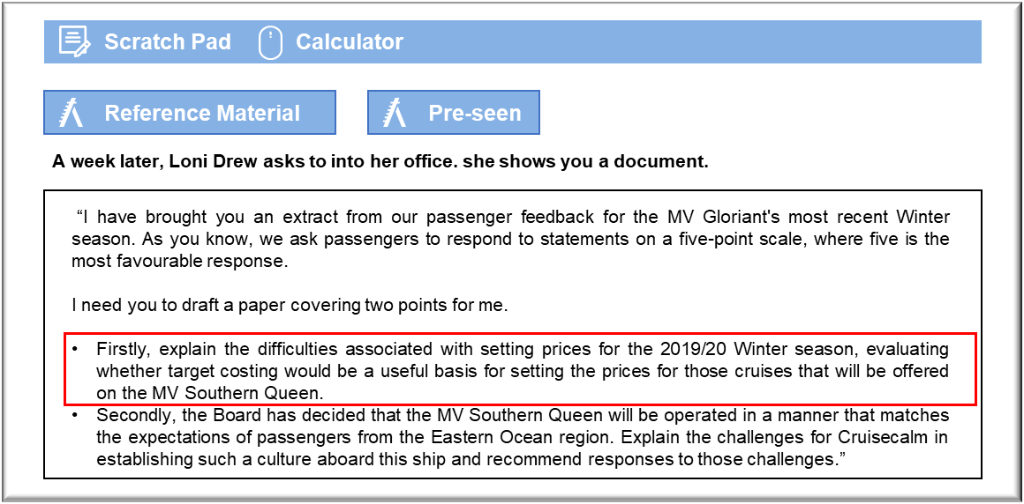

MANAGEMENT CASE STUDY AUGUST 2019 EXAM ANSWERS

Variant2 Task3
These answers have been provided by CIMA for information purposes only. The answers created are indicative of a response that could be given by a good candidate. They are not to be considered exhaustive, and other appropriate relevant responses would receive credit.

CIMA will not accept challenges to these answers on the basis of academic judgement.

Requirement 1: Pricing and target costing
The usefulness of target costing depends on having the ability to determine the price that the market would pay for a product. That can then be adjusted for the required profit per unit to establish the maximum that Cruisecalm can afford to pay for that product. The passenger feedback suggests that passengers do not regard the present product as offering good value for money and so it may be appropriate to attempt to reduce costs in order to pass on savings in the form of lower fares. There is, however, a complication in this case because Cruisecalm is new to the market and it now has the opportunity to create a differentiated product. It may be more profitable for Cruisecalm to continue to charge prices that are relatively high and to focus on the quality of the cruises when marketing. The passengers who have cruised with the company were prepared to pay those prices and they do not actively disagree with the suggestion that they would book again.
Rather than being concerned about price, Cruisecalm could adapt the existing cruises for this
market without spending a great deal. If passengers enjoy informal entertainment and activities then it would cost very little to organise events such as quizzes and sports tournaments. If passengers enjoy themselves more then they will be more likely to feel that their cruise offered value for money. In any case, much of the cost of a cruise is discretionary, depending on whether passengers wish to pay for excursions and so on. That suggests that passengers can work towards achieving their own target price.
The refurbishment of the MV Southern Queen might not be the best place to start with in terms of cutting costs because it could prove expensive to rectify any false economies at this stage. Cruisecalm must bear in mind that it is competing in a market that generally strives to offer new and exciting experiences aboard cruise ships. If the focus of the refurbishment is on cutting costs then the market may gravitate towards other ships and other cruise lines. It may be more realistic to market cruises on the basis that they are a relatively expensive way to vacation, but they are enjoyable because expenses are not spared.

Requirement 2: Culture
An entity’s organisational culture can be described in terms of the entity’s prevailing attitudes and norms. In the case of Cruisecalm, the organisational culture has developed in response to meeting the needs and expectations of passengers from Norland. Cruisecalm is a service organisation that has a high degree of interaction with its customers when they are aboard its ships. There is a danger that the expectations of customers from the Eastern Ocean will not be met because crew members will not understand what these passengers expect of them.
The first challenge is in understanding what passengers from this region actually want and
expect. It will take more than just feedback forms to give Cruisecalm the necessary
understanding. Cruisecalm has been successful in creating an ambience that suits passengers from Norland and surrounding countries, but that has led to shared values amongst crew members that are not particularly appropriate for this new market. That creates a problem in this case because crew members will not necessarily realise that they need to adapt and they will require specific training in order to help them do so.
The second challenge is that passengers from Norland may book cruises on the MV Southern Queen and could be disappointed that the service that is being offered does not meet their expectations. Attempting to meet the needs of both passengers from Norland and those from the Eastern Ocean region may lead to neither group being satisfied. In the age of social media, any such discontent could lead to poor online reviews and could discourage future bookings.
The first challenge might be overcome by recruiting as many customer service staff as possible from other cruise lines that operate in the Eastern Ocean region. The MV Southern Queen will be a new addition to the Cruisecalm fleet and so a crew will have to be recruited anyway. Staff with experience of providing an acceptable cruise experience in that region would be able to develop programmes and train colleagues who have been transferred from elsewhere in Cruisecalm.
The second challenge might be overcome through specific branding of the cruises aimed at
passengers from the Eastern Ocean region. Passengers would then book in the knowledge that they should expect a more informal and relaxed atmosphere. That branding would make it possible to differentiate cruises on the two ships, so that Cruisecalm could offer two types of cruise in that region, with each meeting the needs of different target markets. The focus of any such branding, and any associated advertising, should be on the features of the cruise on offer. That would avoid any sense of discrimination or exclusion on the grounds of nationality of passengers.

